GFWC FLORIDA DISTRICT 4
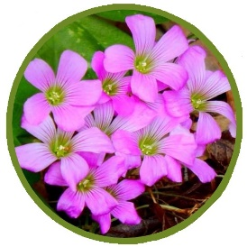
2023
November
04 Lake Shore Woman’s Club Treasure & Craft Sale 8am – 2pm For more information contact Anita Ray 904-699-2399
09 Southside Woman’s Club of Jacksonville Celebrating 110th Club Birthday at General Meeting “Women Inspiring Community Spirit”
10-11 Crescent City Woman’s Club Christmas Craft & Bake Sale Friday 8am-4pm Saturday 8am-3pm Contact: Connie Angevine 386-748-0030
11 Woman’s Club of Welaka Annual Holiday Bazaar 9am-2pm Crafted Items Pick up a hot dog lunch and see the Bake Sale for dessert.
17 District 4 Meeting Woman’s Club of Palatka Each Club Brings a Cake to Raffle
December
3-7 GFWC Florida Bahamas Cruise with President Linda O’Toole to benefit Camp Boggy Creek Abora Travel Dream Vacations www.gfwcfltravel.com Contacts: Laura Connelly 727-201-1822 Diana Pimenta 813-435-9023
08 District 4 Woman’s Club of Mcclenny “Christmas Gathering” CREWS BARN, 6852 Cattle Gap Ln, Glen St. Mary, FL 32040 Bring Camp Boggy Creek Items: Boggy Bears, Curtains, Afghans, and Bright Color Children Print Twin Sheet Sets (NO Solid Colors, No Holiday Print, No Violence)
09 Lake Shore Woman’s Club Holiday Trip to Savannah $150 per person Includes: Bus, Lunch Provided and attending the 3pm show “A Christmas Tradition” at the Savannah Theatre Arrive at 8am at Lake Shore Woman’s Club to board bus.
09 GFWC Woman’s Club of Palatka Christmas Home Tour 2023 Tickets $30 10am – 4pm 11+ Historic Homes throughout Palatka For more information call 904-377-5044
15 Orange Park Woman’s Club “An Old-Fashioned Holiday” Open House 4-8pm Come take a tour of our historic building during the Concert on the Green’s Cocoa and Carols event, taking place on River Road.

15 Camp Boggy Creek Tour Official Tour of Camp Boggy Creek Contact: Deborah Johnson
2024
January
19 District 4 Meeting Woman’s Club of Stark Each Club Brings a Loaded Handbag to Raffle
20 Orange Park Woman’s Club Roarin’ 20’s on the River – Annual Charity Gala $75 pp 6-10pm The Club Continental 2148 Astor St Orange Park, FL 32073 Enjoy a variety of delicious cuisine from local Chefs and live music by the Clay County Community Jazz Band. Silent auction, 50/50, raffles, prize for best themed dress, and more, for. A cash bar will be available. All drawings and auction items will be announced at 9:00 pm.
Monthly Happenings
Wednesday (November 15th chg. due to Thanksgiving )
Lake Shore Woman’s Club plays BUNCO 1:00-3:00 pm Cost is $5.00 Bring a Snack
Contact Sherry Basford 904-524-7343 or Wanda Gad 484-767-6450

Special Fundraisers
Jaguar Mini Helmet Autographed by Quarterback Trevor Lawrence
General Fundraiser for GFWC Lake Shore Woman’s Club
Drawing during December 7, 2023, Meeting Tickets 1 for $5 3 for $10 8 for $20
Contact: Paula Mundy 904-403-4660 or Nancy Ware 904-412-6770

Bring your D4 PASSPORT with you every time you visit a sister club or attend a GFWC event. Ask that it be “stamped” with location and date. Foreign travel (outside of D4) also counts!
Does your club have an event coming up? Would you like to reach more clubs? When your club has a special project, event or fundraiser, email Paula Mundy pmundy48@gmail.com to add to Distric4’s Upcoming Events
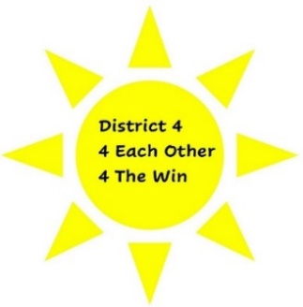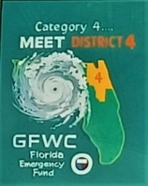
We want you to be in it “4 The Win”

